**Dojo and Ninjas Assignment**

In this assignment, you will be creating an application that will keep track of dojos and all the ninjas that are part of a specific dojo.

ERD and Wireframe

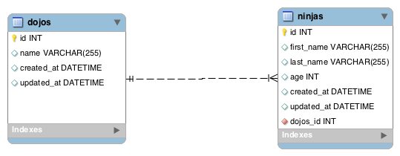

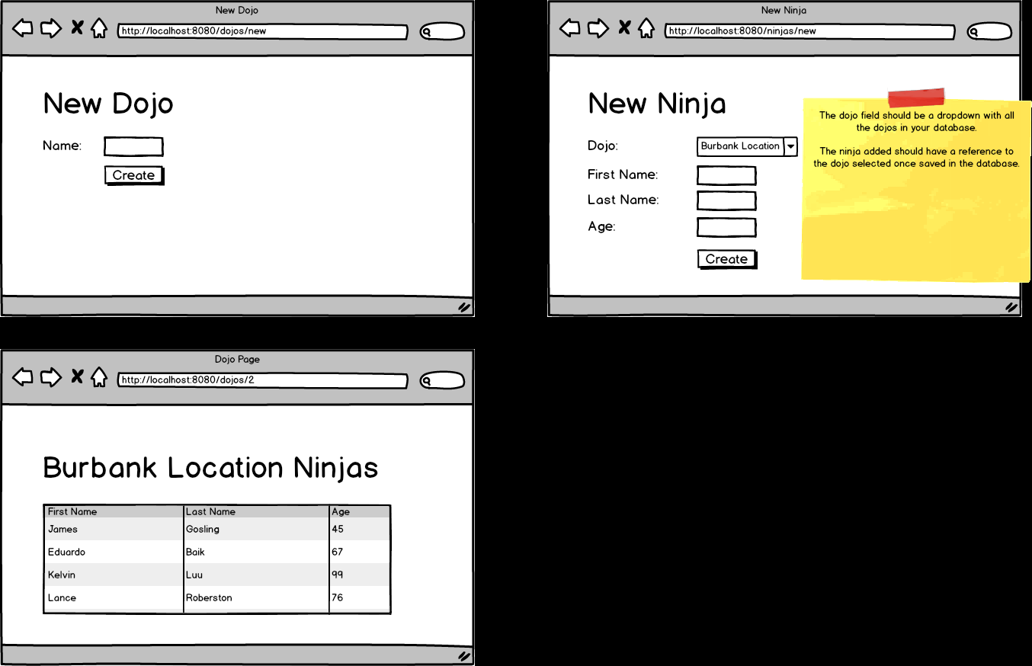

Topics:

* One-To-Many relationships
* JPA

Tasks:

* Allow users to create a new dojo.
* Allow new ninjas to choose their dojo via a dropdown
* Have a dojo show page show information of all the ninjas that belong to that specific location.